Increasing trend (might be continuous or recent)

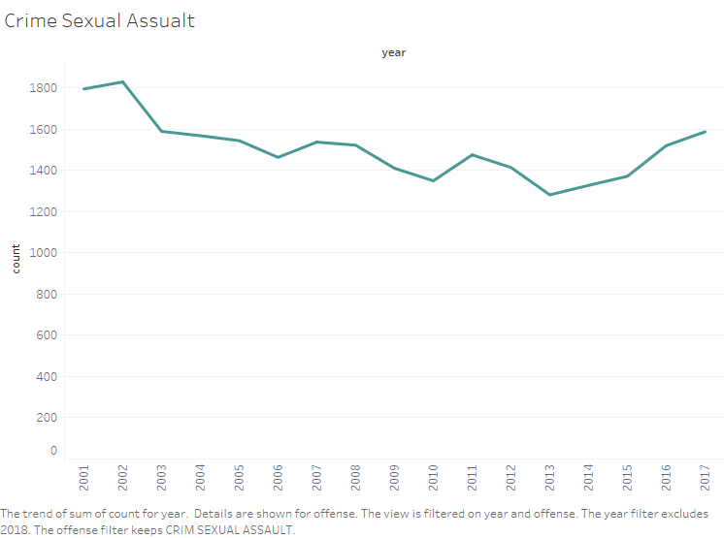

An increasing trend can be seen in Sexual Assault in Chicago since 2013.

There was a change in policy in 2014 which broadened the scope of sexual assaults. This could be one of the reasons for this increase crime.

Link to this could be found here:

<http://chicago.cbslocal.com/2015/10/14/fbis-new-rape-definition-leads-to-a-more-comprehensive-look-at-chicago-crime/>

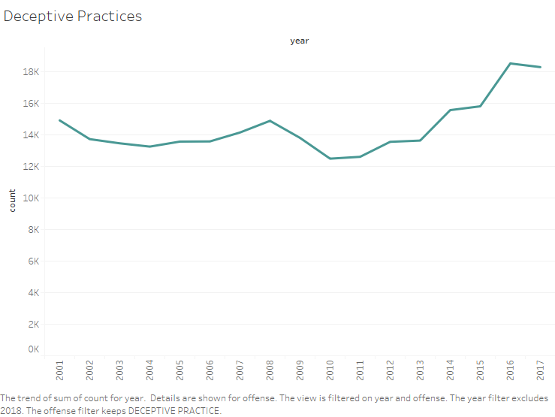

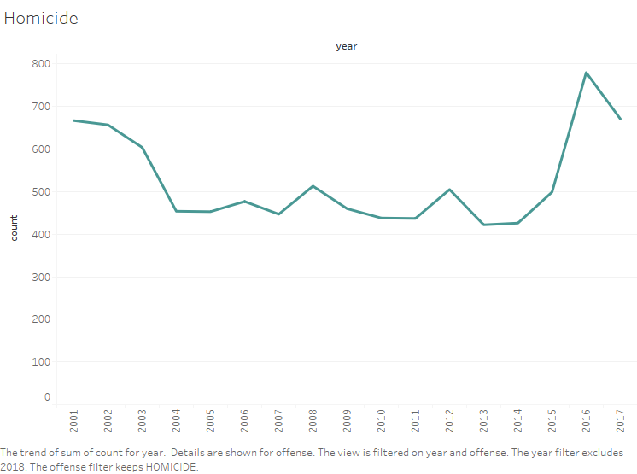

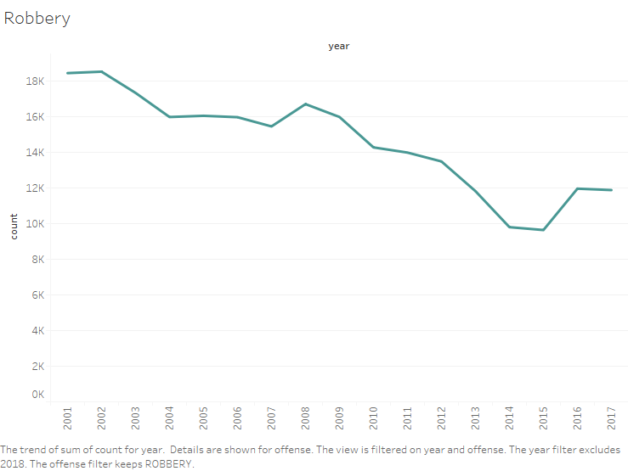

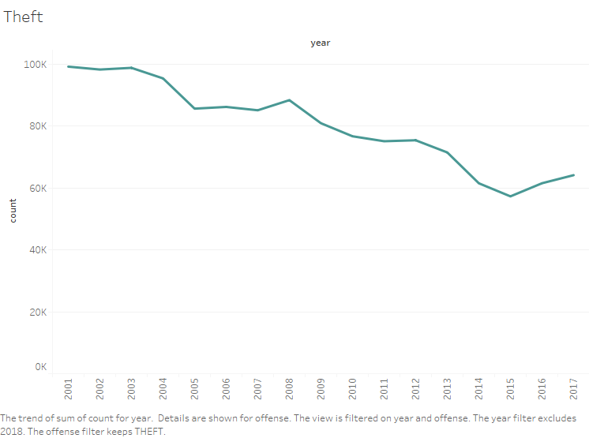

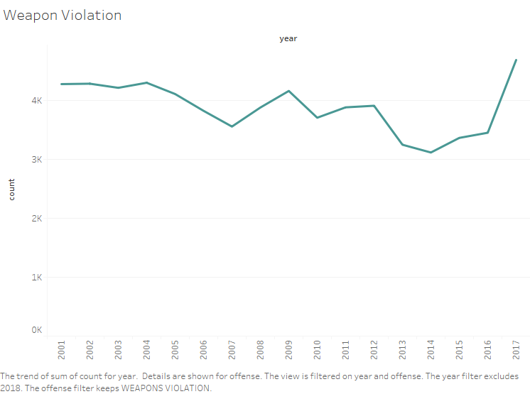

Decreasing trend (might be continuous or recent)

